|  |
| --- |
| Your Cystic Fibrosis Application |
| Design Document   Name: Lorcan BerminghamStudent Number: C00196903November 6, 2017 |

### Tutor: Dr Joseph Keogh

Contents

System Architecture 4

Database Layout 5

Patient Detail Use Case’s 6

Login 6

Medical Profile 7

Register 8

Food Diary 8

Activity 10

Spirometer 11

Logout 12

Doctor Detail Use Case’s 13

Login 13

Manage Patients 13

Logout 14

System Sequence Diagram’s 15

Patient Sequence Diagrams 15

Register 15

Login 16

Food Diary 17

Activity 18

Spirometer 19

Doctor Sequence Diagrams 20

Login 20

Manage Patient’s 21

Screens 22

Splash Screen 22

Login 22

Register/Information 23

Home/Food Diary 23

Lunch 24

24

Activity 25

Moderate Activity 25

Spirometer 26

# System Architecture

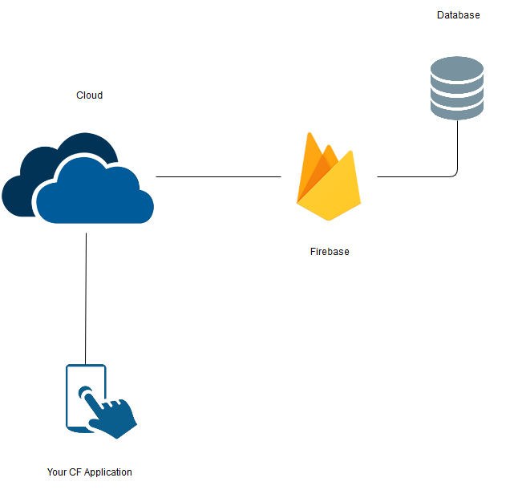

# Database Layout

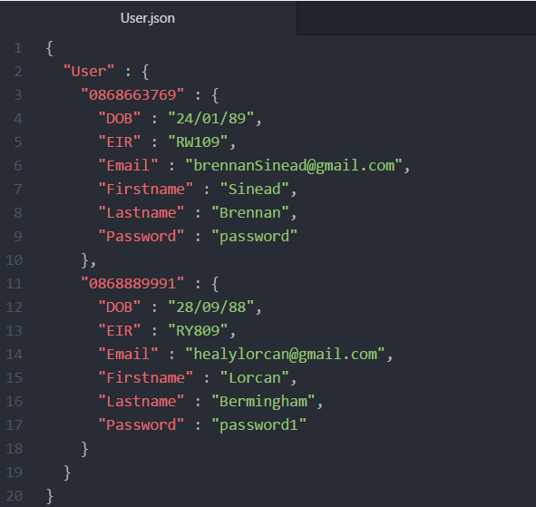

# 

# Patient Detail Use Case’s

## Login

|  |  |
| --- | --- |
| Name | Login |
| Actors | Patient, Firebase |
| Main Success Scenario | 1. Use case begins when the patient opens the application 2. Patient enters mobile number and password 3. Patient selects login 4. The application calls on firebase to check the user and returns the object 5. Use case ends when patient is logged in |
| Alternatives | * 3a password is incorrect   Application display an error warning  Return to step 2   * 3b phone number is incorrect   Application displays error warning  Return to step 2 |

## 

## Medical Profile

|  |  |
| --- | --- |
| Name | Medical Profile |
| Actors | Patient, Firebase |
| Main Success Scenario | 1. Use case begins when the patient opens the application 2. Patient navigates to the medical profile tab 3. A form loads for the patient to fill out 4. Patient fill out the form 5. The use case ends when the patient has finished filling out the form |
| Alternatives | * 3a the form doesn’t load   Application display an error warning  Return to step 3   * 3b the patient can’t navigate to the medical profile tab   Application displays error warning  Return to step 2 |

## Register

|  |  |
| --- | --- |
| Name | Register |
| Actors | Patient, Firebase |
| Main Success Scenario | 1. Use case begins when patient opens the application 2. Patient selects register which then displays an information page 3. Patient is then redirected to the register page 4. Patient is prompted to enter account details 5. Entered details are checked against users in firebase 6. Once the details have been checked the patient is redirected to the login page 7. The use case ends when the patient has logged in |
| Alternatives | * 4a phone number already exists   The application displays the number already exists  Return to step 4   * 4b characters have been entered instead of numbers   Application displays numbers only  Return to step 4 |

## Food Diary

|  |  |
| --- | --- |
| Name | Food Diary |
| Actors | Patient, Firebase |
| Main Success Scenario | 1. Use case begins when a patient has logged in 2. Firebase loads stored image urls and names for the food diary 3. Patient is brought to the home page which doubles as the food diary 4. Patient can select breakfast, lunch, dinner or snacks 5. Patient selects one of the above-mentioned options 6. Firebase loads the names and images from the database depending on which option was selected. 7. Patient selects a food item from the selected food group. They are then met with a short description, there calorie counter for the day, the quantity of items they wish to choose and the specific calorie count of the food they have selected 8. Once the item and the amount have been selected the application will automatically subtract that amount from there predefined amount set to the patient and update that amount in firebase along with the food details. 9. This use case ends when the user logs out |
| Alternatives | * 2a the images don’t load when the user logs in   The application displays empty cards only with the name  The application tries to reload the images   * 4a the application fails to load the selected food area   The patient selects a food group and the application fails to load the selected food group  The application refreshes and tries again |

## Activity

|  |  |
| --- | --- |
| Name | Activity |
| Actors | Patient, Firebase |
| Main Success Scenario | 1. Use case begins when a patient has logged in 2. Patient selects Activity from the menu 3. Firebase loads stored image urls and names for the activity 4. Patient is brought to the activity page 5. Patient can select Light, Moderate, or Vigorous activities 6. Patient selects one of the above-mentioned options 7. Firebase loads the names and images from the database depending on which option was selected. 8. Patient selects an activity from the chosen activity group. The Patient is met with a short description and can select how long they want to do the chosen activity. 9. Once the activity and the length have been selected the application will automatically multiple the length of time by the predefined number set to that activity and update that score in firebase along with the activity. 10. The use case ends when the patient leaves the activity menu |
| Alternatives | * 3a the images don’t load when the user selects activity   The application displays empty cards only with the name  The application tries to reload the images   * 9a the application fails to load the selected activity area   The patient selects a activity group and the application fails to load the selected activity group  The application refreshes and tries again   * 9b the application makes the wrong calculation   The application makes an error when calculating the activity’s score  The application flags the error and try’s again |

## Spirometer

|  |  |
| --- | --- |
| Name | spirometer |
| Actors | Patient, Firebase, Spirometer |
| Main Success Scenario | 1. This use case starts when the patient receives a push notification to do their spirometer 2. The patient navigates to the spirometer tab in the menu 3. The patient can optionally choose to follow a guide explaining how to use the spirometer 4. The patient is redirected to spirometer page. 5. The patient starts the timer and enters the result of each of the three tests they have completed. 6. The patient stops the timer and clicks the submit button 7. The application takes the three input values converts it from a String into a INT and the values are added together and divided by three to get the average of the three attempts. The new average and the time are then sent to the database 8. This use case ends when the patient closes the spirometer tab |
| Alternatives | * 1a the patient doesn’t receive a push notification   The patient isn’t informed to do the spirometer test  The system notices that the test has been completed and tries to resend the push notification   * 5a the timer doesn’t start   The patient clicks the timer to start and it falls to start  The system refreshes the page |

## Logout

|  |  |
| --- | --- |
| Name | Logout |
| Actors | Patient, Firebase |
| Main Success Scenario | 1. The use case starts when the patient is logged in 2. The patient selects the logout tab 3. The use case ends when the patient is logged out |
| Alternatives | * 2a the logout tab doesn’t work   The patient selects the logout tab and it doesn’t work  Return to step 2 |

# Doctor Detail Use Case’s

## Login

|  |  |
| --- | --- |
| Name | Login |
| Actors | Patient, Firebase |
| Main Success Scenario | 1. Use case begins when the doctor opens the application 2. Doctor enters username and password 3. Doctor selects login 4. The application calls on firebase to check the user and returns the object   Use case ends when doctor is logged in |
| Alternatives | * 3a password is incorrect   Application display an error warning  Return to step 2   * 3b phone number is incorrect   Application displays error warning  Return to step 2 |

## Manage Patients

|  |  |
| --- | --- |
| Name | Manage Patients |
| Actors | Doctor, Patient, Firebase |
| Main Success Scenario | 1. This use case begins when the doctor has logged in 2. The doctor selects the manage patient tab 3. The doctor selects the patient they wish to monitor 4. The doctor then can review the selected patient’s data |
| Alternatives | * 1a the doctor cannot login   The doctor receives an error when trying to login  Return to step 1   * 3a the patients are not displayed   The doctor selects the manage patient tab and noting is displayed  Return to step 2 |

## Logout

|  |  |
| --- | --- |
| Name | Logout |
| Actors | Doctor, Firebase |
| Main Success Scenario | 1. The use case starts when the patient is logged in 2. The patient selects the logout tab   The use case ends when the patient is logged out |
| Alternatives | * 2a the logout tab doesn’t work   The patient selects the logout tab and it doesn’t work  Return to step 2 |

# System Sequence Diagram’s

## Patient Sequence Diagrams

### Register

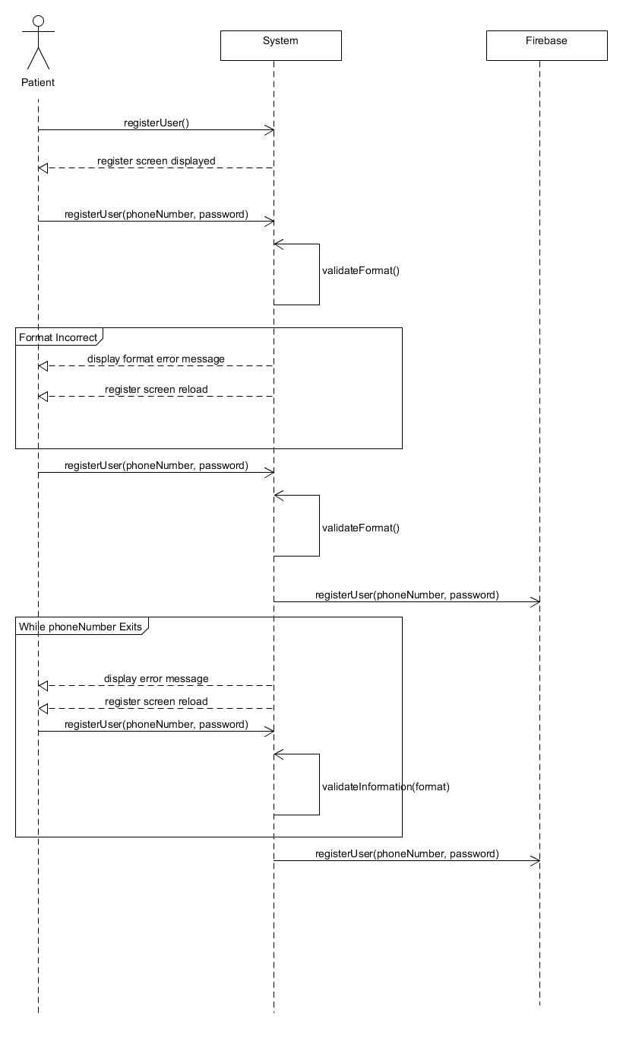

### Login

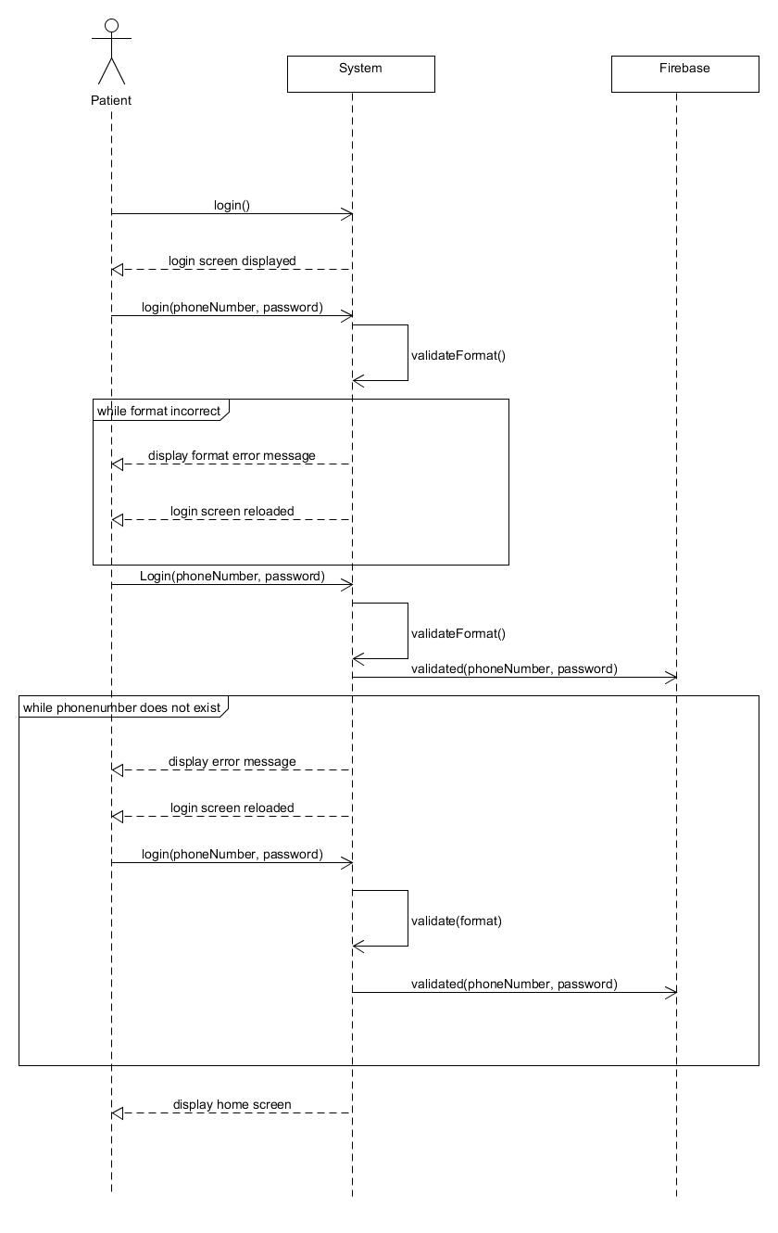

### Food Diary

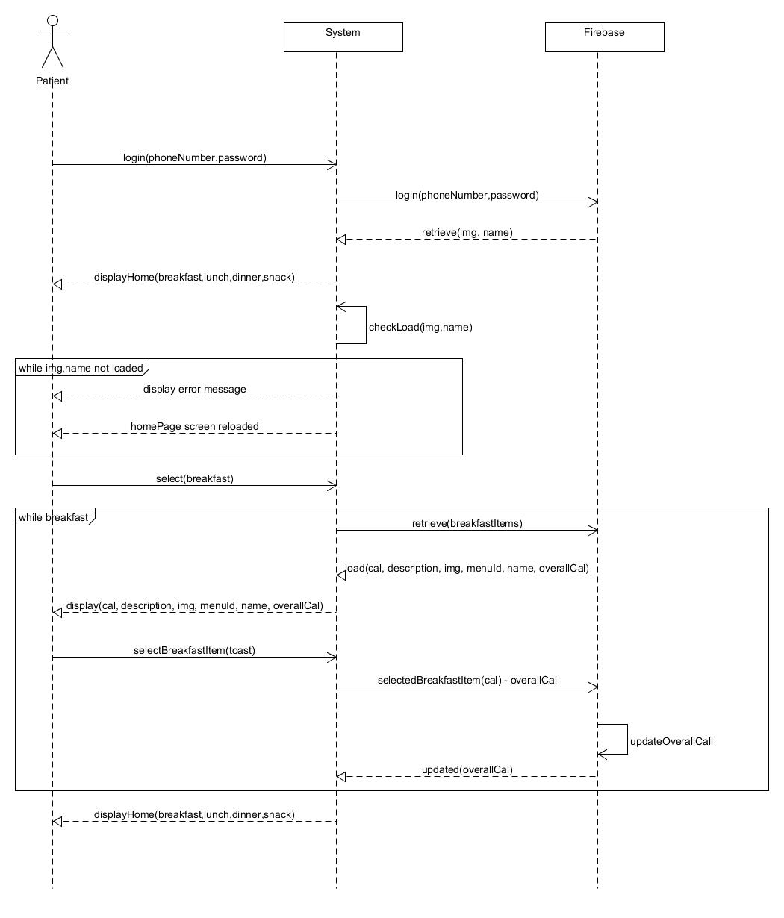

### Activity

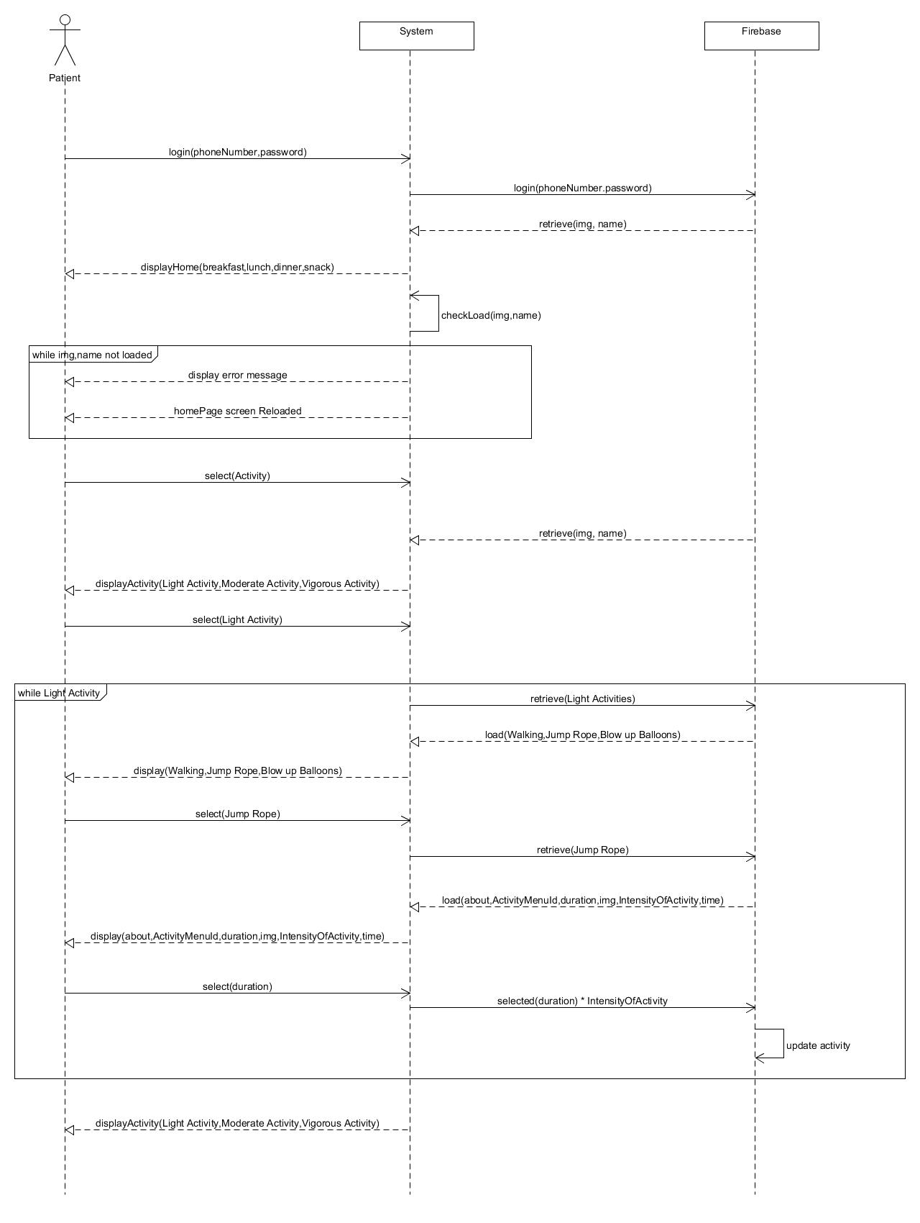

### Spirometer

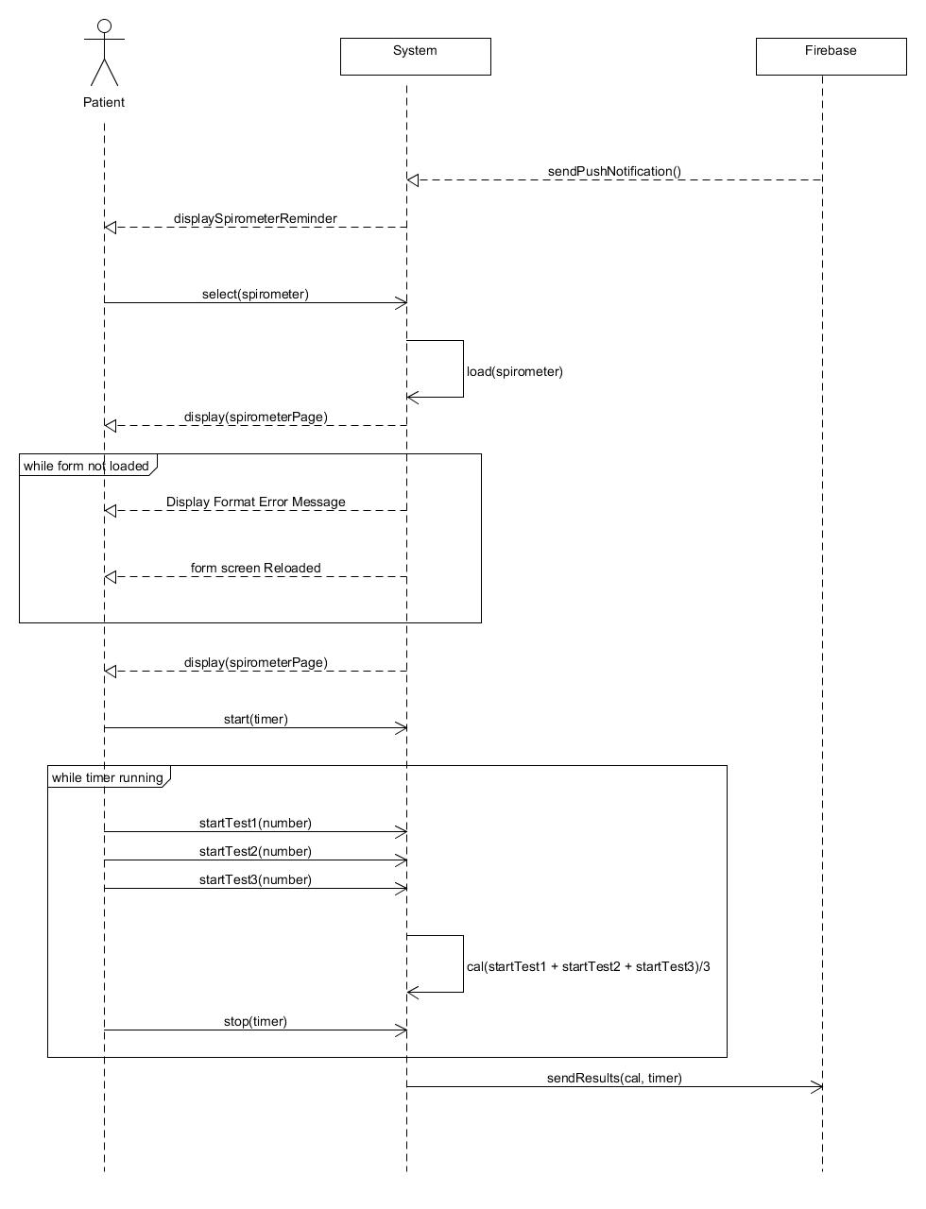

## Doctor Sequence Diagrams

### Login

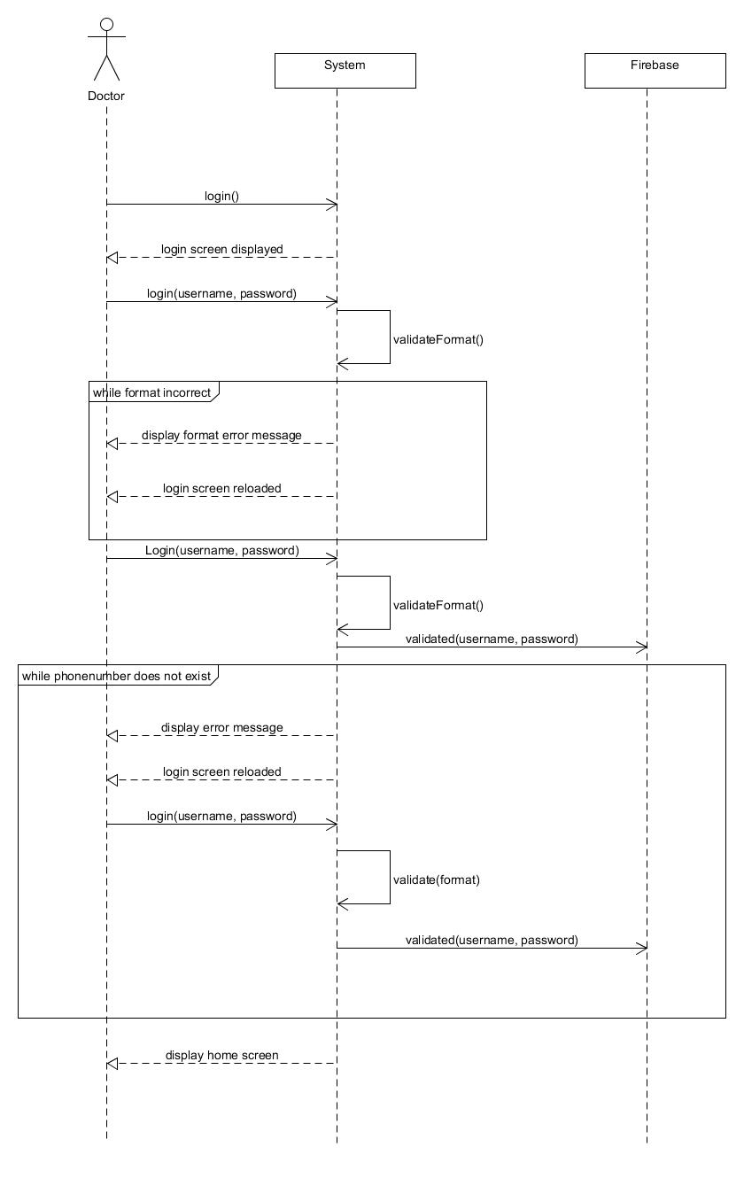

### Manage Patient’s

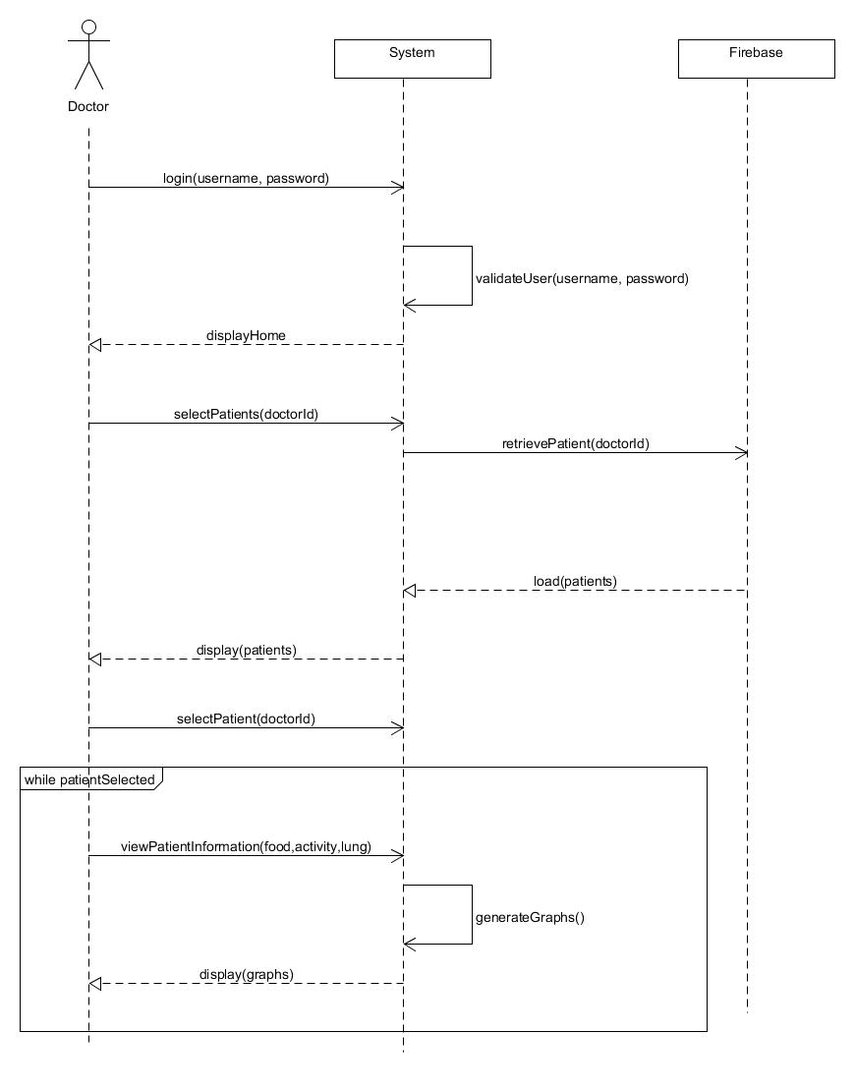

# Screens

## Splash Screen

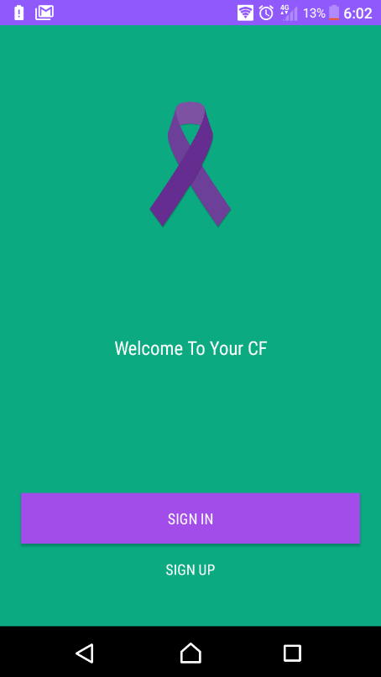

## Login

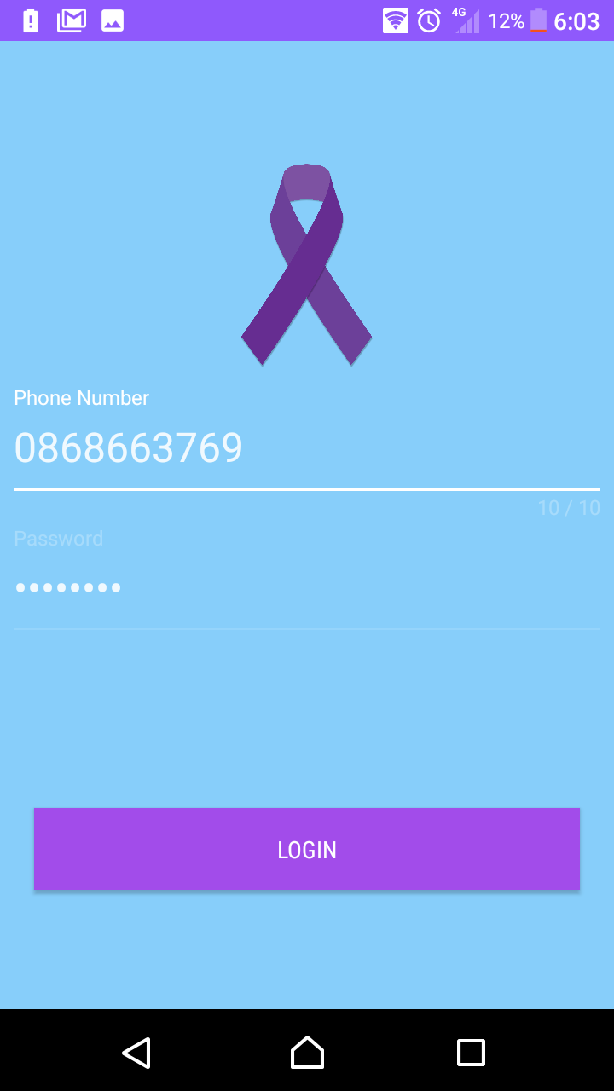

## Register/Information

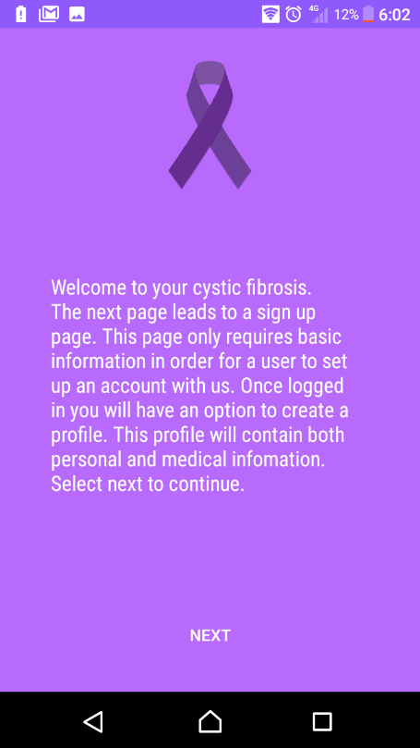 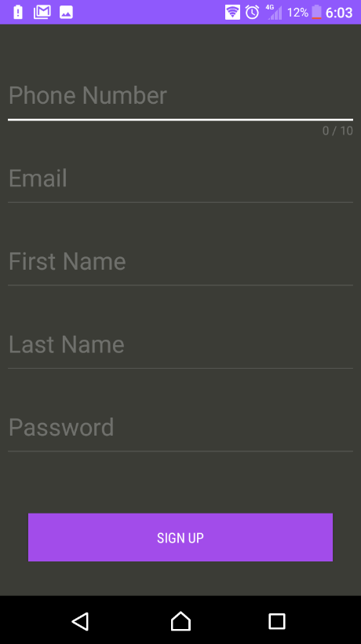

## Home/Food Diary

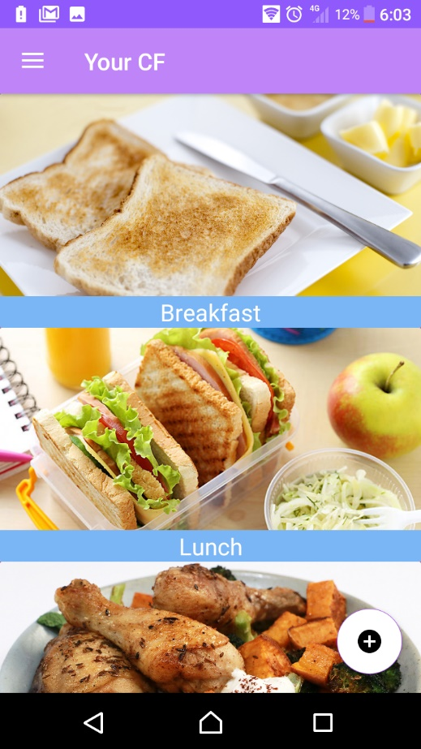

## Lunch

### 

## Activity

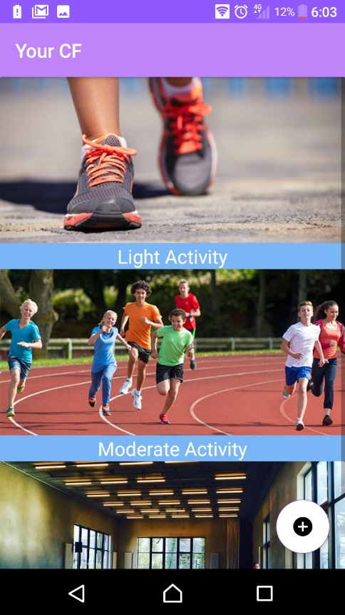

### Moderate Activity

#### 

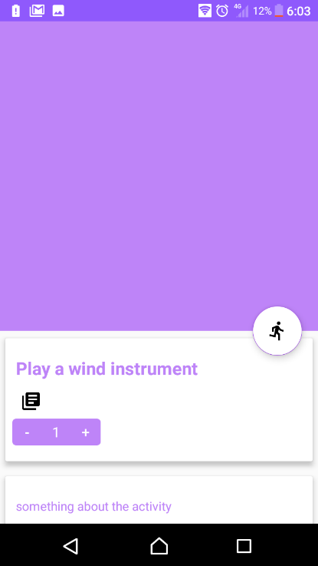

## Spirometer

